Homo Noxis
Foucault Pendulum Blueprint
Corrected Hall of Ceremony Geometry - Hollow Cone, Pillar Ring, Long Return

Locked correction
The top-down plan is correct: a great circular Hall, a central forbidden code circle, a second concentric Pillar Ring with five Kahir pillars forming a pentagram, and a final outer ambulatory where the people, candidates, processions, and Kahir doors belong.
The previous vertical section was wrong because it made the five supports look like slanting ribs leaning from the floor toward the crown. The corrected model is different: the Hall is a hollow cone, but inside the cone stands a vertical five-pillar ring, almost like a sacred cylindrical colonnade. The pillars rise vertically from the Pillar Ring to an upper annular support ring. Above that ring, the hollow cone continues upward to the high crown where the pendulum is suspended.
So the correct mental image is not a tent held by five slanted poles. It is a gigantic mined conic void with five colossal vertical pillars around the forbidden centre, linked by a pentagram on the floor and by magnificent upper stonework.
The Mountain was mined upward to make room for the one line it could not command.

1. The exact Hall shape
The Hall of Ceremony is a vast hollow cone mined upward into the Mountain. The base is a great flat circle. The ceiling narrows as it rises until it reaches the high crown or suspension cap. From that crown descends the pendulum Thread.
At floor level, the Hall is made of three concentric zones:
- The forbidden central pendulum/code circle, where nobody may stand because the pendulum sweeps this space and the Long Return is read there.
- The Pillar Ring, where the five colossal Kahir pillars stand and define the pentagram support geometry.
- The Great Ambulatory, the outer circular corridor where the people gather, where processions move, and from which doors open toward Kahir-specific chambers.
The centre is therefore not a dais. It is an absence protected by law. No Keeper stands there. No altar stands there. No Candidate is named there. The centre belongs to the pendulum alone.

2. The corrected vertical architecture
The five pillars are vertical. Each rises from the Pillar Ring to a high annular support ring. This ring catches and redistributes the load of the hollowed Mountain. It also creates the visual cylinder inside the cone: a sacred inner cage around the forbidden circle.
The conical roof-shell continues above the upper support ring toward the crown. The pendulum thread descends through the centre of this structure, passing through the open axis created by the pentagram and the annular rings. The bob hangs above the forbidden circle.
The star is not only drawn on the floor. It is structural and liturgical. On the floor, the pentagram links the bases of the pillars. Above, the pillars are joined by annular and crossing supports. The Hall is therefore a machine for keeping a vast vertical emptiness open inside the Mountain.
The people stood in the ring. The Keepers stood at the pillars. The pendulum alone crossed the forbidden circle.

3. Corrected diagrams

Top-down plan - approved geometry
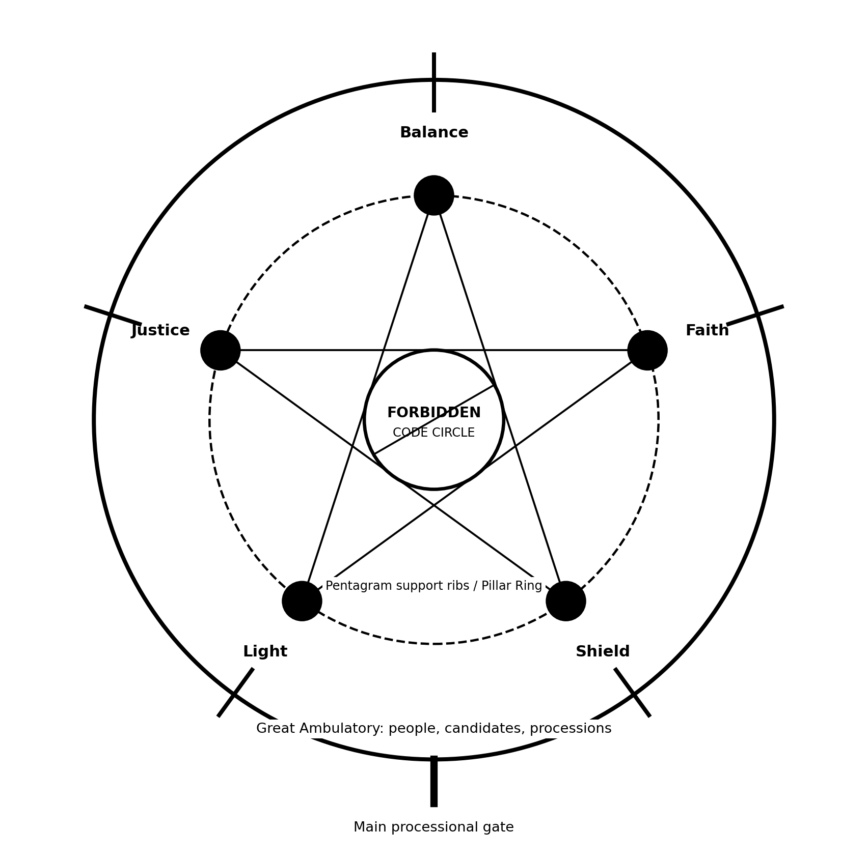
Top-down plan: outer ambulatory, five Kahir pillars on the Pillar Ring, pentagram support geometry, and central forbidden code circle.

Vertical section - corrected geometry
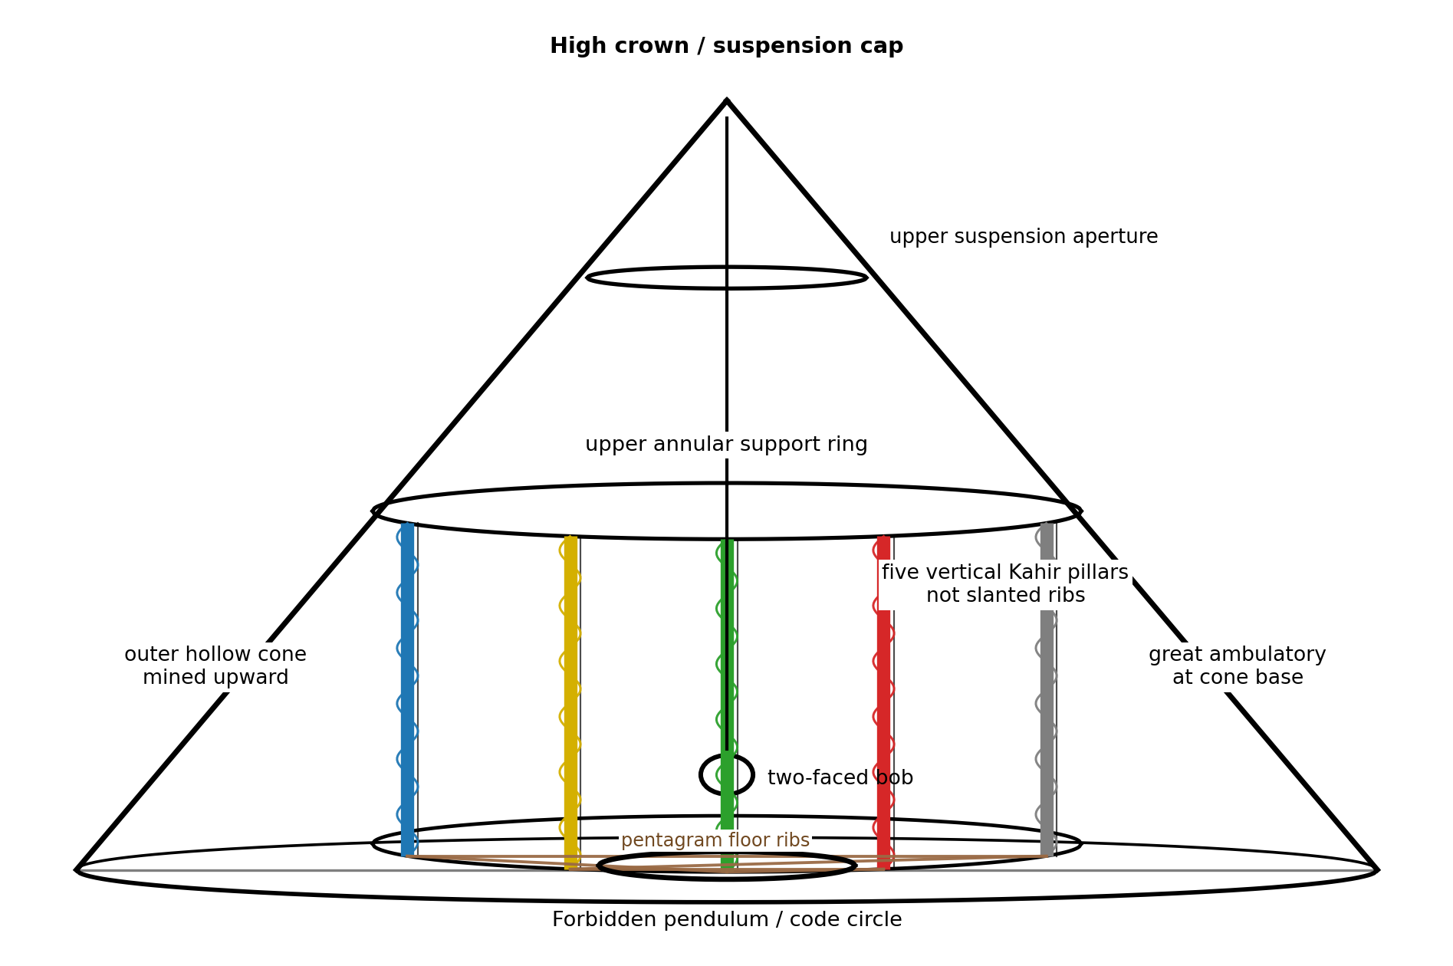
Corrected vertical section: hollow cone, vertical Kahir pillars, upper annular support ring, high suspension crown, central Thread, and forbidden floor circle.

4. Kahir order and spatial stations
The canonical clockwise order remains Balance, Faith, Shield, Light, Justice, following the Book of Blood naming of the first Keepers. The Hall teaches Kahir-order before compass-order.
Each Kahir has three spatial expressions in the Hall: a pillar on the Pillar Ring, a sector of the ambulatory, and a door leading outward into Kahir-specific territory.
- Balance: pillar of water, measure, provision, stores, and the cost of survival.
- Faith: pillar of prayer, rhythm, echo, memory, Long Return, and seismic resonance.
- Shield: pillar of threshold, defence, containment, and the refusal of danger before explanation.
- Light: pillar of sight, angle, aperture, refraction, witness through image, and the discipline of seeing.
- Justice: pillar of sequence, record, law, witness, correction, and consequence.
The Kahir doors open from the outer ambulatory, not from the central circle. This matters because no office owns the centre. Every office approaches the centre from its own station but cannot occupy it alone.

5. Ceremony positioning

Keepers
Keepers stand at or just before their own pillars. They face inward across the forbidden circle, toward the pendulum and the opposite offices. Authority is radial, not central. A Keeper is powerful because his or her pillar bears part of the Mountain, not because he or she occupies a throne.

Veils
Veils stand slightly behind and inward of their Keeper, closer to the central danger but still outside the forbidden circle. The spatial grammar is precise: the Veil is nearer than the Candidate, not yet central, and never owner of the whole.

Candidates
Candidates stand in the outer part of their Kahir sector, between the people and the Pillar Ring. During Ascension they are summoned inward toward the pillar, not toward a dais. The Candidate’s movement is therefore from public ring to office pillar, not from crowd to stage.

People
The common people stand in the Great Ambulatory and any stepped galleries carved into the outer circular wall. They see the five pillars and the pendulum but cannot enter the Pillar Ring without permission. They witness the architecture of divided knowledge without possessing its meaning.

Processions
Processions enter through the main gate into the Great Ambulatory. From there they move circularly, not straight toward the centre. This lets the Hall stage hierarchy through rotation: a body may be brought past all five Kahir stations before being admitted to its own.

6. The pendulum and the forbidden centre
The forbidden central circle is both safety-zone and doctrine-zone. Practically, nobody can stand where the pendulum swings. Ritually, nobody may stand where the Still Line is read. Technically, the code marks and prayer marks belong to this circle. The line crosses it; people do not.
The Foucault period remains tied to the Mountain’s latitude east of Ouadane and south of Taoudenni: about sixty-five hours for one full apparent rotation. Faith names this the Long Return.
The swing-plane is not a God-to-Beast arrow. The line is the Still Line: the proof that the Mountain turns beneath the pendulum. The ritual faces of the bob supply the prayer mode; the line supplies the cosmic proof.

7. Corrected God / Beast symbolism
The earlier image of people praying toward God with the Beast behind their backs is rejected as spatially false. When a worshipper faces a sacred object, the reverse face is not behind the worshipper. It is behind the face the worshipper is allowed to see.
Therefore, the stronger doctrine is this: the Beast is not behind the faithful. The Beast is behind what the faithful are allowed to face.
The pendulum bob may be a two-faced sacred body. One face is Godward. The reverse is Beastward. In Godward prayer the people see the God-face. In Beastward remembrance the Hall may reveal the reverse, not as worship, but as warning, command, and containment.
The Beast was not behind the faithful. It was behind the face the faithful were allowed to see.

8. Prayer modes in the corrected Hall
Because the Hall is circular, prayer is not a simple act of facing one wall. It is a staged orientation of the whole congregation around the moving evidence of the pendulum. Faith appoints the face, the sector, the response, and the order of address.
Prayer mode | Pendulum face | Spatial emphasis | Meaning
Godward / Promise | God-face visible | Faith pillar leads; all five answer | God keeps His promise: the hidden people endure, the waters continue, and restoration remains possible.
Beastward / Remembrance | Beast-face revealed | Justice and Shield prominent | The Beast is enemy, chained defence, and buried danger. It must remember who is friend and who is foe.
Defence Given by God | God-face with Shield sector lit | Shield pillar | God-given defence remains obedient: sword, threshold, seal, warden, containment.
Provision | God-face with Balance sector lit | Balance pillar | God provides water, food, oil, warmth, medicine, fibre, and the time survival consumes.
Chains / Keepers | Both faces acknowledged in sequence | All five pillars in order | The Keepers keep their separate charges and keep the Beast chained beneath the Earth.
Threshold / Outsider | God-face; Beast-face veiled | Shield and Faith | God keeps the Outsider out and prevents stolen holy speech from returning as hunger.

9. The Heart-Stone / recharging mechanism
The pendulum is never recharged by touching the bob or pulling the Thread. That would allow human hands to command the sacred line. Instead, the Hall contains a hidden Heart-Stone mechanism in the service cavities beneath or around the Pillar Ring.
Faith attendants, sometimes with Balance assistance, raise a heavy stone counterweight through a concealed winding passage. As the Heart-Stone descends, it powers an escapement-like mechanism that gives the pendulum tiny impulses at the right moment. The impulse restores amplitude but does not choose direction.
Raise the Stone. Feed the Thread. Do not command the Line.

10. Divided knowledge
- Common people know where to stand, which face is revealed, and that the forbidden circle must never be crossed.
- Children learn that the God-face is trust, the Beast-face is warning, and the Thread belongs to God.
- Faith attendants know the Long Return as sacred rhythm and arrange prayers around the shifting line.
- Veils of Faith learn that the apparent turning is caused by Earth rotating beneath the Hall.
- The Keeper of Faith understands the spherical Earth, seismic wave propagation, global resonance, and why the Beast belongs to the physics of the whole Earth.
- Light understands reference frames, sight, angle, and the trick that what seems moving may be still.
- Balance understands mass, length, damping, suspension, maintenance cost, and the Heart-Stone.
- Justice records the line, the cycle, deviations, and sequence of rites.
- Shield understands why the device is dangerous: it proves the Mountain is not the final frame.

11. Ceremony rule going forward
Every future ceremony in the Hall of Ceremony should be staged from this geometry: no dais, no central speaker, no throne. The Hall is a hollow conic chamber whose authority is distributed around a forbidden centre. The five pillars bear the Mountain, the outer ring holds the people, the Kahir doors open from the ambulatory, and the pendulum alone crosses the centre.
This changes how scenes must be written. Characters do not simply “walk to the dais.” They move from ring to ring: from gate to ambulatory, from ambulatory to Kahir sector, from sector to pillar, and never into the forbidden centre unless the scene is one of catastrophic breach.
The old visual grammar of dais, speaker, crowd is replaced by circle, forbidden centre, five pillars, outer ring, and moving line.

